Project Design Phase-II
Data Flow Diagram & User Stories

Date | 27 September 2026
Team ID | SWTID-2026-5034
Project Name | AI BlogNest API
Maximum Marks | 4 Marks

Data Flow Diagrams:
A Data Flow Diagram (DFD) is a traditional visual representation of the information flows within a system. A neat and clear DFD can depict the right amount of the system requirement graphically. It shows how data enters and leaves the system, what changes the information, and where data is stored.
Example: DFD Level 0 (Industry Standard)
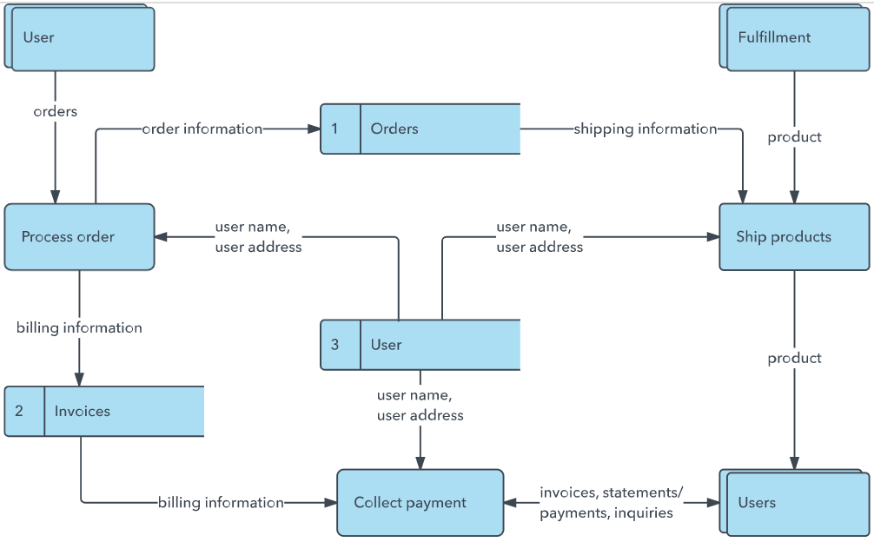
Example: (Simplified)


User Stories
Use the below template to list all the user stories for the product.
User Type | Functional Requirement (Epic) | User Story Number | User Story / Task | Acceptance criteria | Priority | Release
Customer  (Mobile user) | Registration | USN-1 | As a user, I can register for the application by entering my email, password, and confirming my password. | Account should be Created successfully. | High | Sprint-1
User | Login | USN-2 | As a user, I can login using my email and password | User should receive authentication access. | High | Sprint-1
User | Blogs | USN-3 | As a user, I can create a new blog. | Blog should be saved successfully. | High | Sprint-1
User | Blogs | USN-4 | As a user, I can view available blogs. | Blog details should be displayed. | High | Sprint-1
User | Blogs | USN-5 | As a user, I can update my blog. | Updated blog should saved. | Medium | Sprint-2
User | Blog Management | USN-6 | As a user , I delete my blog. | Blog should be deleted successfully. | Medium | Sprint-2
User | AI Blog Generation | USN-7 | As a user, I can generate blog content using AI. | AI-generated content should be displayed. | High | Sprint-2
User | Content Summarization | USN-8 | As a user, I can summarize blog content using AI. | A short summary should be generated. | High | Sprint-2
User | Authentication | USN-9 | As a user, I can access protected APIs after login. | Unauthorized users should be denied access. | High | Sprint-1
User | Error Handling | USN-10 | As a user,I can receive proper error messages for invalid requests. | Appropriate error response should be displayed. | Medium | Sprint-2

